|  |  |
| --- | --- |
| EGC_Black | Student Name \_\_\_\_\_\_\_\_\_\_\_\_\_\_\_\_\_\_\_\_\_\_\_\_\_\_\_\_\_    **Eastern Goldfields College**  Mathematics Essentials 2015  Application 3 – Leavers  1 |

**TIME:** 50 min  **TOTAL MARKS**: 35

This practical application is worth 8% of your course mark.  
 **Equipment needed**: calculator, notes, ruler and atlas (Longman 5th ed)

Soon you will be finishing school and you want to celebrate this event. In November this year, students celebrate the end of school life by participating in ‘Leavers’, also known as ‘Schoolies’. There are three possible options available to you, they are:

* travel to Hong Kong in China;
* travel to ‘Schoolies’ on the Gold Coast in Queensland; or
* stay home and go to a local party.

In this application, you are required to determine travel distances, time and packing requirements to travel to these and other destinations around the world.

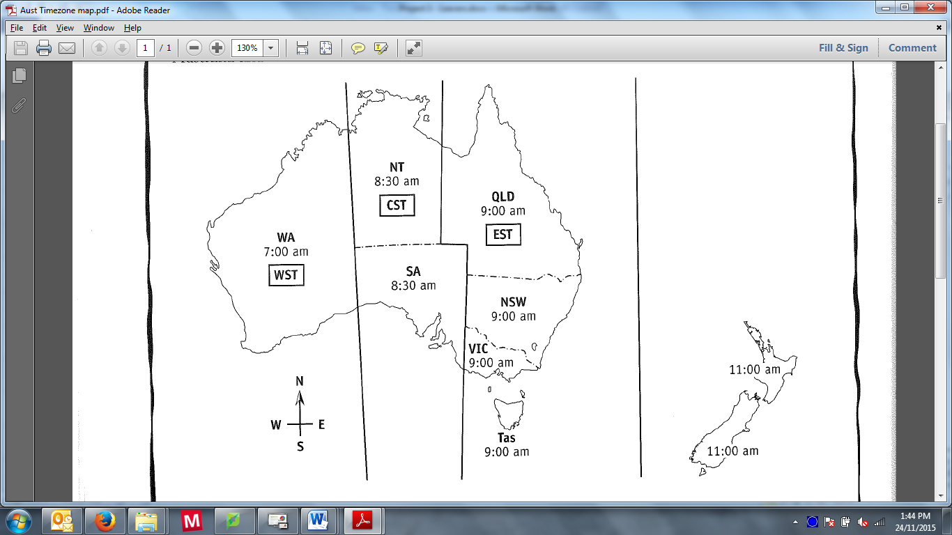

Australian Standard Time is divided into three sections:

* EST – Eastern Standard Time
* CST – Central Standard Time
* WST – Western Standard Time

Note: To move from west to east, add on the time difference. To move from east to west, subtract the time difference.

**Question 1 (4 Marks)**

Complete the table below to show the local time in each region.

|  |  |  |  |
| --- | --- | --- | --- |
| **WST** | **CST** | **EST** | **New Zealand  Standard Time** |
| 6:15 am |  |  |  |
|  | 2:30 pm |  |  |
|  |  | 1:45 pm |  |
|  |  |  | 11:10 am |

**Question 2 (3 Marks)**

Use the atlas provided and the page numbers listed to answer this question.

To the nearest 5 degrees, determine the approximate global position using latitude and longitude of each of the following locations:

* Perth (page 83) \_\_\_\_\_\_\_\_\_\_\_\_\_\_\_\_\_\_\_\_\_\_\_\_\_\_
* Hong Kong (page 83) \_\_\_\_\_\_\_\_\_\_\_\_\_\_\_\_\_\_\_\_\_\_\_\_\_\_
* Gold Coast (page 60) \_\_\_\_\_\_\_\_\_\_\_\_\_\_\_\_\_\_\_\_\_\_\_\_\_\_

**Question 3 (6 Marks: 3, 3)**

1. Use the arc length formula to calculate the global distance between Perth and Hong Kong. Show your working.

1. Using the scale and map on page 10 of the atlas provided, estimate the distance, as the crow flies, between Perth and Gold Coast. Show your working.

**Question 4 (7 Marks: 3, 2, 2)**

1. The flight from Perth to Hong Kong takes approximately 8 hours, what time would you arrive in Hong Kong if you left Perth at 9:00 am, in:
2. WST time? \_\_\_\_\_\_\_\_\_\_\_\_\_\_\_\_\_\_\_
3. Local, Hong Kong, time? \_\_\_\_\_\_\_\_\_\_\_\_\_\_\_\_\_\_\_
4. The flight from Perth to Gold Coast takes approximately 5 hours, what time would you arrive in Gold Coast if you left Perth at 9:00 am, in
5. WST time? \_\_\_\_\_\_\_\_\_\_\_\_\_\_\_\_\_\_\_
6. Local, Queensland time? \_\_\_\_\_\_\_\_\_\_\_\_\_\_\_\_\_\_\_
7. The Gold Coast is in Queensland; however this city has grown so large that it has merged with Tweed Heads. Tweed Heads is the northern most city of New South Wales. Similar to Kalgoorlie merging with Boulder. New South Wales has daylight savings during ‘Schoolies’ whereas Queensland does not.

If you were to walk along the Coolangatta beach on the Gold Coast at 3:30 pm and enter the beach at Tweed Heads 5 minutes later, what time would it be when you step onto the Tweed Heads beach?

**Question 5 (2 Marks)**

Do the following flights cross the International Date Line?

* 1. Perth to Hong Kong Yes / No (circle)
  2. Perth to Gold Coast Yes / No (circle)

**Question 6 (5 Marks: 2, 1, 2)**

Using your results from Question 2 and the general rule that every 15o east advances the time by one hour, and every 15o west decreases the time by one hour, estimate the number of hours ahead, or behind, Greenwich Mean Time (also known as UTC) it will be in the following locations?

1. Perth

1. Hong Kong

1. Gold Coast

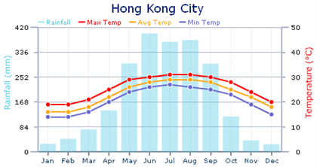**Question 7 (7 Marks: 2, 1, 4)**

Use the graphs on the right to assist in answer the following questions.

1. What information do these graphs provide?
2. What month of the year is ‘Leavers’?

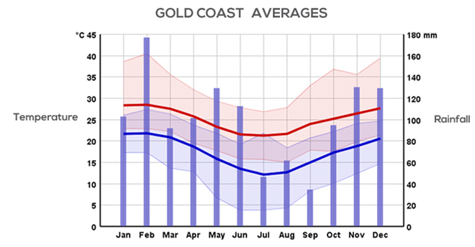

1. For each of the following ‘Leavers’ destination options list the items of clothing you would pack and why.   
   Hint: use the “What on Earth am I Wearing” image to assist with your list.

Hong Kong

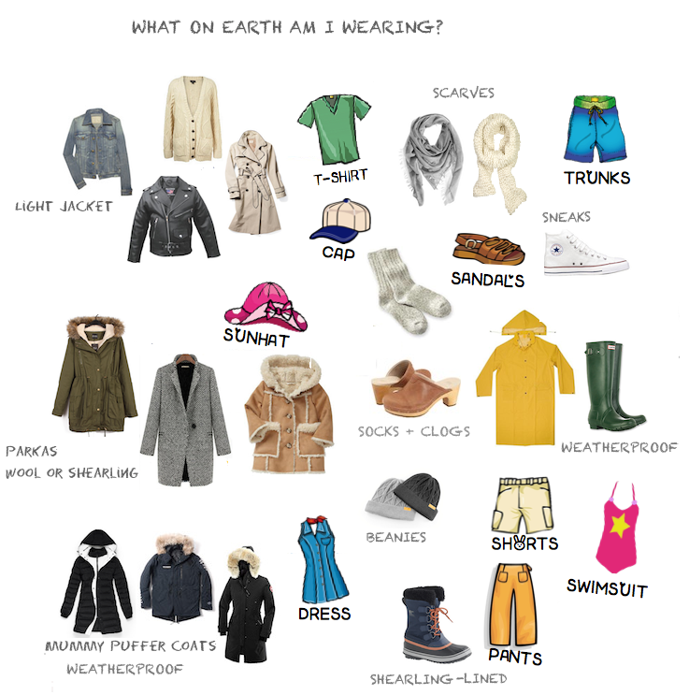

Gold Coast